Digital Design

CSCE 2114-L007

Blake Fasse

March 28, 2017

[bafasse@uark.edu](mailto:bafasse@uark.edu)

**Introduction**

This lab was intended to help learn to design a complex circuit to make an adder/sub and how to simulate it in order to make sure that it works. The complex circuit was designed in Quartus on the computer and simulated using the same program. Expected results from this lab are when the add/sub is active high it initiates addition and when it is active low it initiates subtraction.

**Design**

Using the computer program Quartus, the lab asked to have a complex circuit designed to make an adder/sub. The add/sub IC could be found in the MegaWizard Plug-In Manager in the program. Once the add/sub IC was placed on the board it required three inputs and one output with two of those inputs being any two numbers that are being used and the third input being the add/sub input. A picture of the circuit is shown below.

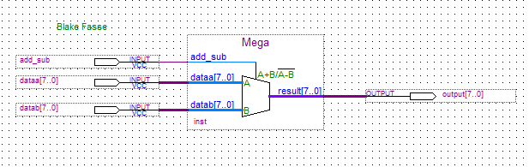

**Results**

The results of the lab show that when the add/sub input is active high then the two inputs are added and when it is active low the inputs are subtracted. Also when the add/sub is active high then it forces data input B to 0 and adds that to whatever data input A is whereas when it is active low it does the exact opposite where it forces data input A to a 0 and subtracts whatever data input B is. A picture of the vector waveform is shown below.

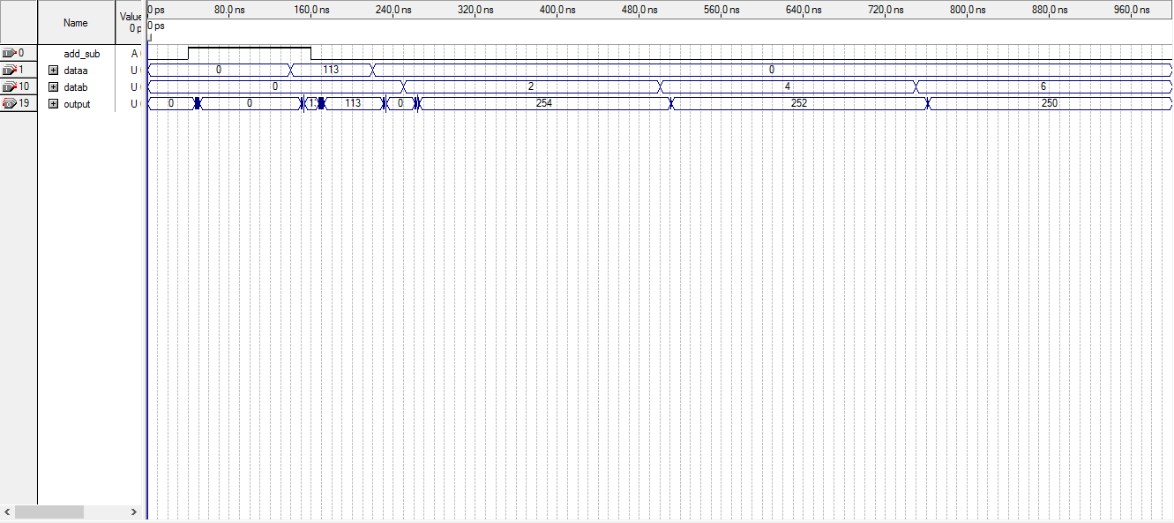

**Conclusion**

Creating the add/sub was not hard at all but figuring out what the waveform was trying to tell was a little bit challenging. Quartus made the process of building this circuit very easy.